Project 3 | Circular Linked Lists
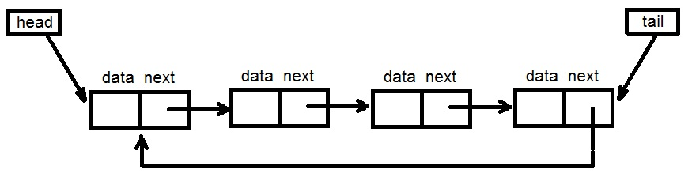

For this assignment, you will need to implement –
- A generic circular singly-linked list class with and iterator
- A generic sorted double singly-linked list class with an iterator that inherits from your generic circular linked class

A GUI has been provided for you for this assignment to help you visualize your linked list. Your list classes will also be tested with Junit tests.

Academic Honesty Policy Reminder | Do your own work – each submitted project will be compared against other submissions from current and previous semesters.

Specifications

BasicDoubleLinkedList

This generic double single-linked list relies on a head (reference to first element of the list) and tail (reference to the last element of the list). Both the head and the tail are set to null when the list is empty.

Both point to the same element when there is only one element in the list, and now the element’s “next” reference points to itself. A node structure has only two fields: data and the next references.

The class must only define the following entities –
- An inner class Node
- An inner class that implements ListIterator (for the iterator method)
- Head and tail references
- An integer representing the list size.

However only the next(), hasNext(), previous() and hasPrevious() methods of the ListIterator are required to be implemented by you.

The rest of the methods can throw the UnsupportedOperationException, such as:

public void remove() throws UnsupportedOperationException{
throw new UnsupportedOperationException();}

All the entities are defined as protected so they can be accessed by the subclass. Follow the Javadoc that is provided.

SortedDoubleLinkedList
A generic sorted double linked list will be constructed using a provided Comparator to determine how the list is to be sorted. It extends BasicDoubleLinkedList class.

The addToFront and the addToEnd methods will not be supported and an add method will be added that inserts to the doubly-linked list in sorted order dependent on the Comparator. Follow the Javadoc that is provided.

Exception Handling
- UnsupportedOperationException – this exception is a Java library exception and will be returned by the addtoFront and addToEnd implementations of the SortedLinkedList class and by the remove method of the iterator.
- NoSuchElementException – this exception is a Java library exception and will be returned by the next function within the iterator class when there are no more elements in the linked list.

GUI
A GUI driver has been provided to help you visualize your doubly-linked lists. Here is the minimum that must be in place in order to utilize the GUI effectively.
- All methods in your BasicDoubleLinkedList and SortedDoubleLinkedList must be stubbed.
- The addToFront or addToEnd method of the BasicDoubleLinkedList must be implemented to create a basic doubly-linked list.
- The add method of the SortedDoubleLinkedList must be implemented to create a sorted doubly-linked list.
- The toArrayList method in both the BasicDoubleLinkedList and SortedDoubleLinkedList, which returns an arraylist of the items in the list from the head of list to the tail of list. This method is used to display the contents of the lists.

Testing
- Create a JUnit Test – BasicDoubleLinkedListTest_STUDENT.
- Create a JUnit Test – SortedDoubleLinkedListTest_STUDENT.
- Run provided “public” test cases
- Anticipate “private test cases to be executed by your instructor

Programming Concepts

This project utilizes the following concepts:
- Exception handling
- Generic Classes
- Doubly Linked List
- Ordered Doubly Linked List
- Iterators
- Comparators
Write-up & Submission Requirements
Review the provided rubric to understand project expectations, including documentation, CMSC204, and programming requirements. Two artifacts MUST be submitted for this project: Java source code and a write-up.
At a minimum, the write-up needs to address -
- Approach, design & algorithm
  - DO NOT start coding your project immediately! Come up with a high level design for the project first
    - What’s your game plan to complete the project?
    - Break the project into smallest modules where applicable
    - UML diagrams will go a long way
  - Each student is welcome to expand on the design, if it makes sense. Students will not be penalized for going “above and beyond” specifications of the project
  - Complete this step first, then write your code
- Test Plan & Test Cases
  - Ensure that your project can successfully pass all provided “public test cases.” What other test cases have you attempted?
    - Students should think about potential private tests – what would they be?
  - Your instructor will test your project using an additional set of private test cases as well as the provided public test cases
  - I want to see your “thinking,” in particular, how you are testing your program
  - Each submission should be rock solid, with no bugs
  - Capture screenshots of your test runs in your write-up as you run them
- Highlight your learning experience and lessons learned
  - I am very interested to learn about what you have done, how you did, etc.
- Anything else that you want to share with me
- Take a screen shot of the repo with the directory and files
- If your project is not working as expected, submit it as-is but clearly articulate your situation in your write-up in order to potentially receive partial credit

Each student must submit one compressed (.zip) file back to the Assignment (link) with the following deliverables:
- Your entire Eclipse project folder (Source code included)
- Write-up as a Word or PDF file, one write-up per project
- I WILL compile, run and test every submission using a set of public and private test cases – this is how I test to ensure that your project is working correctly
- Name the compressed file (zip format) as <lastname>_project_x
  - where x is the project number and your last name (e.g. Thai_Project_1.zip)
- Double check your submission, as I can only grade what’s being submitted (don’t assume anything)
- DO NOT email your submission! It won’t be accepted

Not clear? That’s okay, but do ask your questions. “I did not know” or “I did not understand” is not good enough.

Start working on each project immediately so that we can discuss any concerns or questions you have. Reminder – I am unavailable on Saturdays and have limited availability on Sundays.
Sample Test Cases & Outputs (Consider them as a guide only)

Adding to a Basic List Adding to a Sorted List
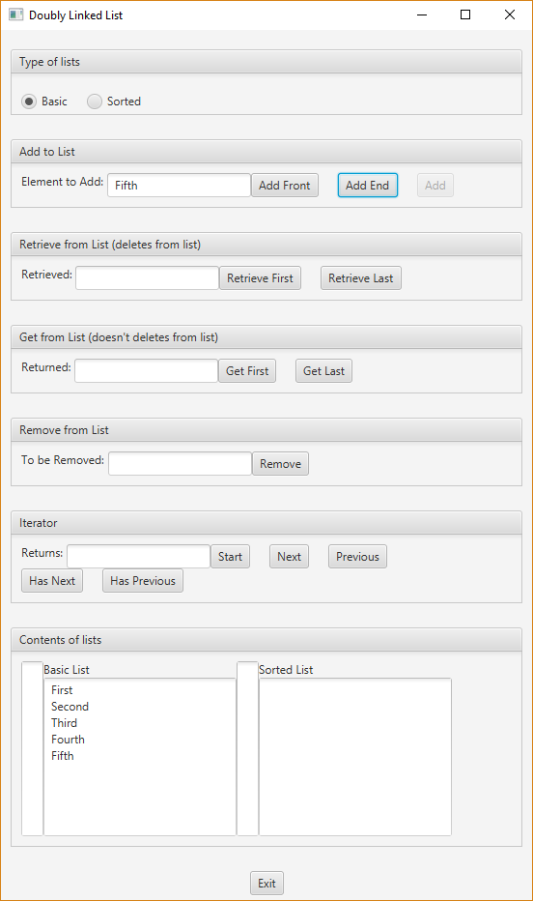
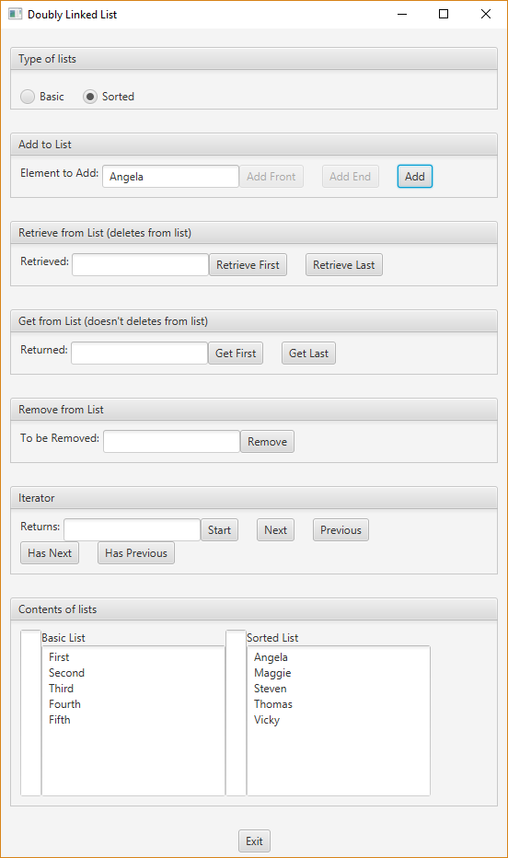

Removing Second from basic Removing Thomas from sorted
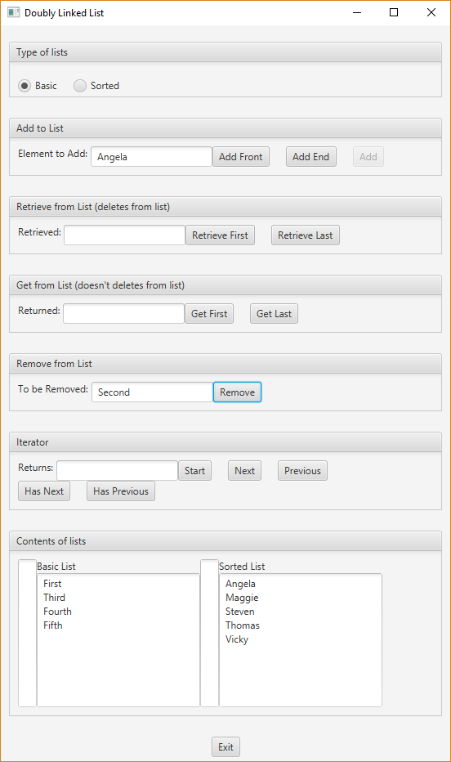
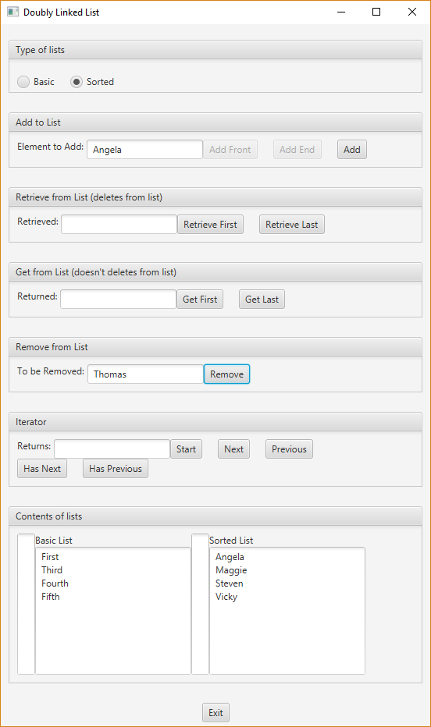

Start the iterators for Basic and Sorted. Think of iterators being “in between” nodes.

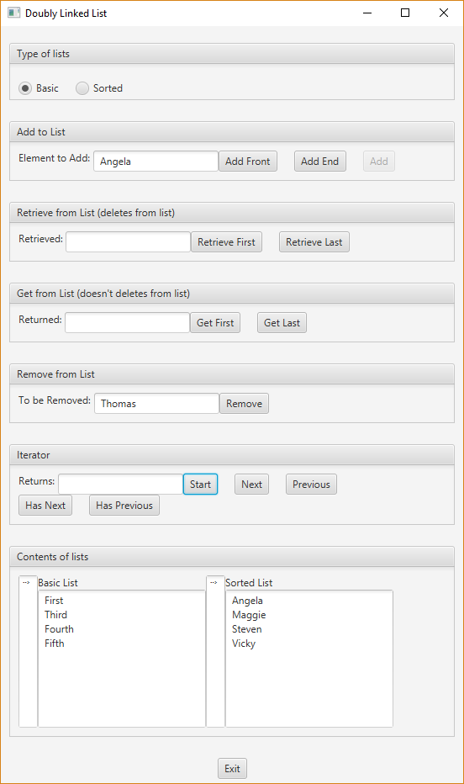

Example of selecting “Next” for Basic and then for Sorted list. Think of iterators being “in between” nodes.
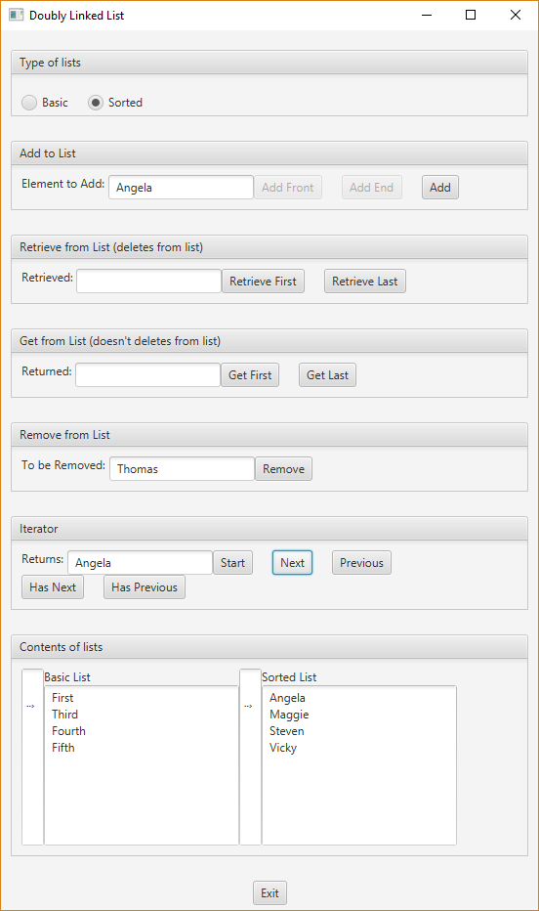
Example of “Next” for basic and “Previous” for Sorted. Think of iterators being “in between” nodes.
